Return To Grace
Wednesday, May 8th, 2019
Enjoy the BEAUTY of the voice, the GRACE of the spirit and the JOY of the memory!!
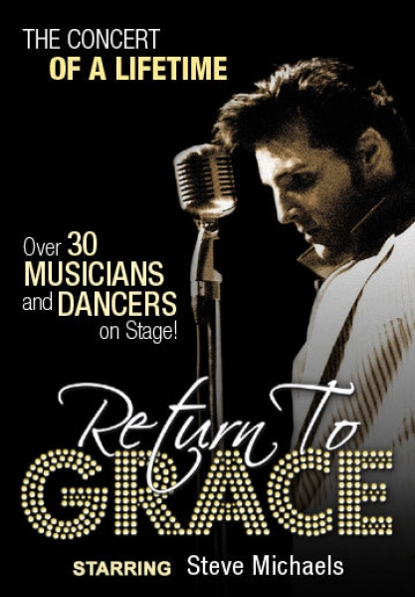
This is not your typical Elvis tribute show that's performed at every local theatre. This is a glorious, heartfelt tribute to a music icon starring Steve Michaels and over 30 performers on stage! Return to Grace traces the greatest musical moments of a generation with song favourites that include "Heartbreak Hotel", "Suspicious Minds", "Love Me Tender", and more! From the King's beginnings in Memphis, to the amazing '68 Comeback Special, to the historical Aloha from Hawaii concert, experience Return to Grace to re-live the music that changed rock and roll forever!

Coach Package Includes:
- Luxury Motor Coach
- Lunch at “Hothouse” Toronto
- Reserved 1:30pm Orchestra Seating at Princess of Wales Theatre
- Meal gratuity
- HST

TICKETS: $180.00 per person

Pick-up Locations

Vaughan Carpool Lot, Colossus Drive, Hwy 400 & Hwy 7
North York – 5 Old Yorkmillls Rd.
Mississauga McDonalds, Hurontario & Courtney Park Drive, Mississauga
Burlington Carpool Lot, Guelph Line & QEW, Burlington
Travel directly to Toronto for lunch. After lunch, make our way to Princess of Wales Theatre for a 1:30 pm matinee performance of Return to Grace. At the completion of the show re-join the Coach for return to your drop off point.
TERMS & CONDITIONS: Full payment due at time of booking. Day Trips are Non-Refundable.

