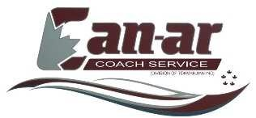

221 Caldari Road, Concord ON, L4K 3Z9
PHONE: (905) 738 2290 Ext: 332 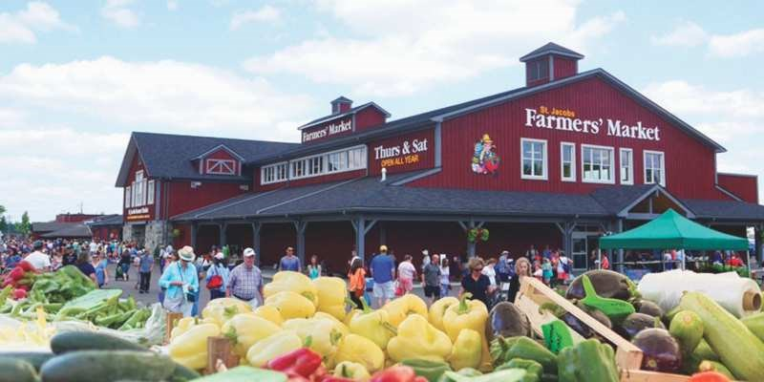
THURS. OCTOBER 12TH 2017

Come and join us on a day trip to St. Jacobs!!! Experience a popular destination within the area with the largest year-round Farmer’s Market that offers locally grown fresh produce, meats, vegetables, baked goods, crafts and more to enjoy. After your visit to the Market well head down to Elmira for a delicious Buffet Luncheon at the popular “Crossroads Restaurant”. Following lunch, we will head back to St. Jacobs where you will be able to spend the rest of the day browsing the beautiful charming village with its delightful shops, crafts, antiques and more.
On departure for home will make a quick stop at Picard’s Peanuts!!!
Return time approximately at 5:00:PM

Tour Includes
Motor Coach Transportation
Lunch at “Crossroads Restaurant” Elmira
Taxes and Meal Tip
Our Pickup Locations
07:30 AM - Vaughan Carpool Lot, Colossus Drive, Hwy 400 & Hwy 7
08:00 AM - York Mills Subway Station, Toronto
08:30 AM -- Mississauga McDonalds, Hurontario & Courtney Park Drive, Mississauga
09:20 AM - Burlington Carpool Lot, Guelph Line & QEW, Burlington

$ 69.00 PER PERSON
Email: betzy@can-arcoach.com , www.can-arcoach.com 50019566

